Alexandria First Presbyterian Church

141 Little York-Mount Pleasant Road
Milford, New Jersey

Founded 1797
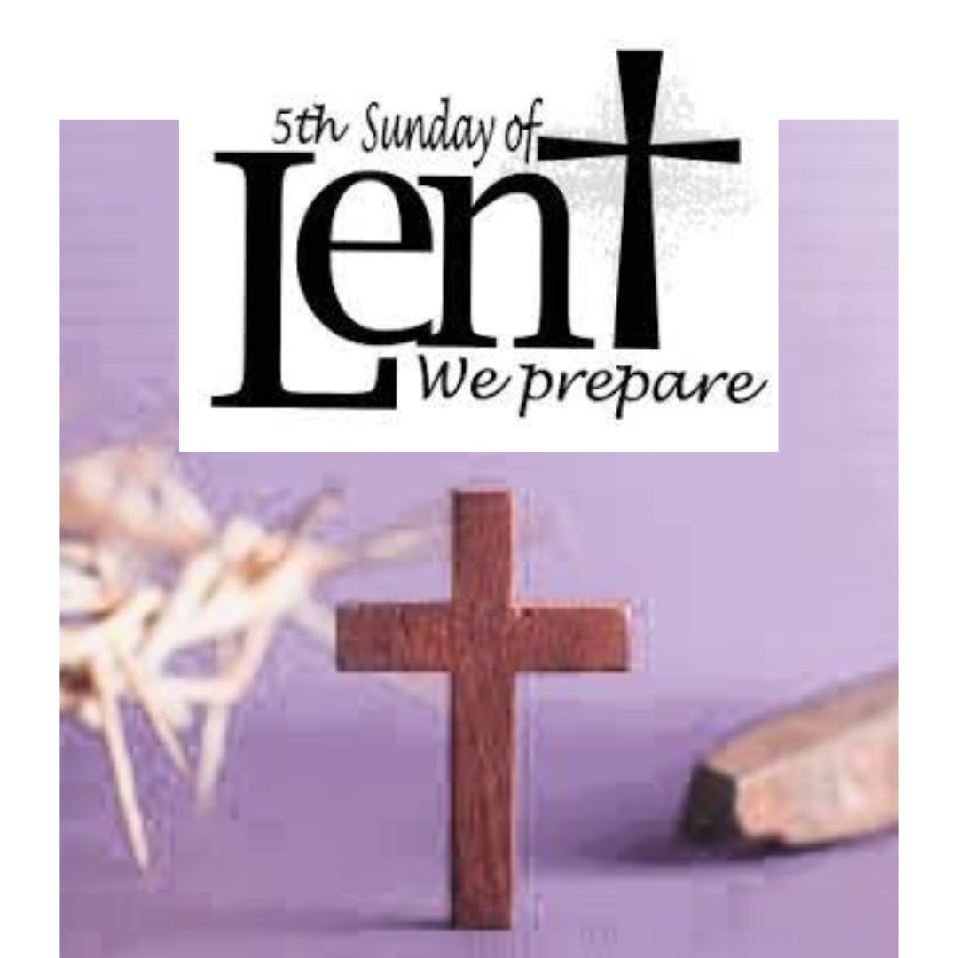

Gathered in God’s grace and led by the Holy Spirit,
Alexandria First Presbyterian Church joyfully worships, prayerfully seeks,
and gratefully shares as a loving family growing in Jesus Christ.

March 26, 2023

10:00 a.m.
Usher: Steve Cameron Worship Assistant: Greg Hedden
Director of Music Ministry: Stefanie Watson Minister: The Rev. Nicholas Hatch

ORDER OF WORSHIP
March 26, 2023 – Fifth Sunday in Lent

THE CHURCH GATHERS . . .

PRELUDE The Valley of Bones Margaret Bonds

WORDS OF WELCOME

MINUTE FOR MISSION Per Capita Marie Knapp

INTROIT Sanctuary
Lord, prepare me to be a sanctuary, pure and holy, tried, and true.
With thanksgiving I’ll be a living sanctuary for you.

*CALL TO WORSHIP
Leader: The Lord is merciful and gracious,
All: slow to anger and abounding in love.
Leader: Jesus said: I am the resurrection and the life.
All: Those who trust in Christ will never die.
Leader: Come, let us worship the Lord.

. . . TO PRAISE AND CONFESS

*HYMN OF PRAISE 85 What Wonderous Love Is This

*LENTEN PRAYER
Lord God, Great I am, you are the resurrection and the life. As we worship you this day show us who we are: bearers of good news, messengers of resurrection; through Jesus Christ our Lord. Amen.

*RESPONSE OF PRAISE (please sing)

What wondrous love is this that caused the Lord of bliss
to bear the heavy cross for my soul, for my soul,

to bear the heavy cross for my soul!

PRAYER OF CONFESSION
God of all consolation and compassion, your Son comforted the grieving sisters, Martha and Mary; your breath alone brings life to dry bones and weary souls. Pour out your Spirit upon us, that we may face despair and death with the hope of resurrection and faith in the One who called Lazarus from the grave.

SILENT REFLECTION AND CONFESSION OF SIN
Leader: Lord, in your mercy, All: hear our prayers.

KYRIE 574 Lord, Have Mercy upon Us
Lord, have mercy upon us. Christ, have mercy upon us.
Lord, have mercy upon us.

ASSURANCE OF PARDON
Leader: Do not fear, says the Lord, for I have redeemed you. I have called you by name; you are mine. And so, I declare to you, in the name of Jesus Christ, you are forgiven.
All: Thanks be to God. Amen.

HYMN 355 Hear the Good News of Salvation
Hear the good news of salvation: Jesus died to show God’s love.
Such great kindness! Such great mercy! Come to us from heaven above.
Jesus Christ, how much I love you! Jesus Christ, you save from sin!
How I love you! Look upon me. Love me still and cleanse within.

THE PEACE
Leader: Since God has forgiven us in Christ, let us forgive one another.
The peace of our Lord Jesus Christ be with you all.
All: And also, with you.
Leader: Staying in our seats, I invite you to turn to your neighbor and greet each other with the Peace of Christ.

. . . TO EXPERIENCE GOD’S WORD

ANTHEM What Wonderous Love is This American Traditional
arr. Watson
CHILDREN’S SERMON
Children are excused for Sunday school.

HYMN 322, remain seated Spirit of the Living God

PRAYER OF ILLUMINATION

FIRST SCRIPTURE LESSON John 11:1-16

SECOND SCRIPTURE LESSON John 11:17-45
Leader: The word of the Lord.
All: Thanks be to God.

SERMON The Glory of God The Rev. Nicholas Hatch

. . . TO RESPOND IN FAITH

*HYMN OF AFFIRMATION 400 When We Are Living

SILENT PRAYER

HYMN, sing twice Hear Our Prayer, O Lord
Hear our prayer O Lord, hear our prayer O Lord.
Incline thine ear to us and grant us thy peace.

PRAYERS OF THE PEOPLE (SHARING JOYS AND SORROWS)
Leader: Lord, in your mercy,
All: hear our prayers.

THE LORD’S PRAYER
Our Father, who art in heaven, hallowed be thy name.
Thy kingdom come, thy will be done, on earth as it is in heaven.
Give us this day our daily bread;
and forgive us our debts, as we forgive our debtors;
and lead us not into temptation, but deliver us from evil.
For thine is the kingdom and the power and the glory, forever. Amen.

PRESENTATION OF TITHES AND OFFERINGS
Offertory Larghetto Elfrida Andrée
*Doxology 592
Praise God from whom all blessings flow;
praise Him, all creatures here below:
praise Him above, ye heavenly host:
praise Father, Son, and Holy Ghost. Amen.
*Prayer of Thanksgiving
. . . TO GO OUT TO SERVE

*CLOSING HYMN 487 When Morning Gilds the Skies

*CHARGE AND BENEDICTION

*CONGREGATIONAL RESPONSE Bless the Lord
Bless the Lord, my soul, and bless God’s holy name.
Bless the Lord, my soul, who leads me into life.

POSTLUDE Springtime Margaret Ruthven Lang

*Please Stand If You Are Able

This week’s sanctuary flowers are given by the Bondor Family to the glory of God in celebration of Springtime!

Announcements

Per Capita Month: For the month of March we are highlighting per capita and encouraging each member to consider contributing. Per capita is $42.50 for each member of AFPC. You may send in your per capita check to the church office or simply put it in the offering plate (with “per capita” in the memo line). Thank you for your continued support and commitment to our church and denomination.

CHRISTIAN RESPONSE to Racism Classes
March 26th Join us after worship in the conference room.

LUNCH BUNCH
March 28th at Noon
Bring your sandwich, chips and drinks will be provided. Bring a friend!

CARE TO SHARE
Care-to-Share is our huge Lenten service project on April 9th. Join us as we prepare 200 lunch bags for Milford, Frenchtown and Flemington Food Pantries. It is amazing to watch God’s people come together for such a great cause. Food tags are in the Narthex.

EASTER LILY ORDER DEADLINE IS MARCH 31ST

SAVE THE DATE
May 5th: Cinco de Mayo Party at the Pardonner’s 6:00pm
August 14-18th: Vacation Bible School at Frenchtown Presbyterian Church

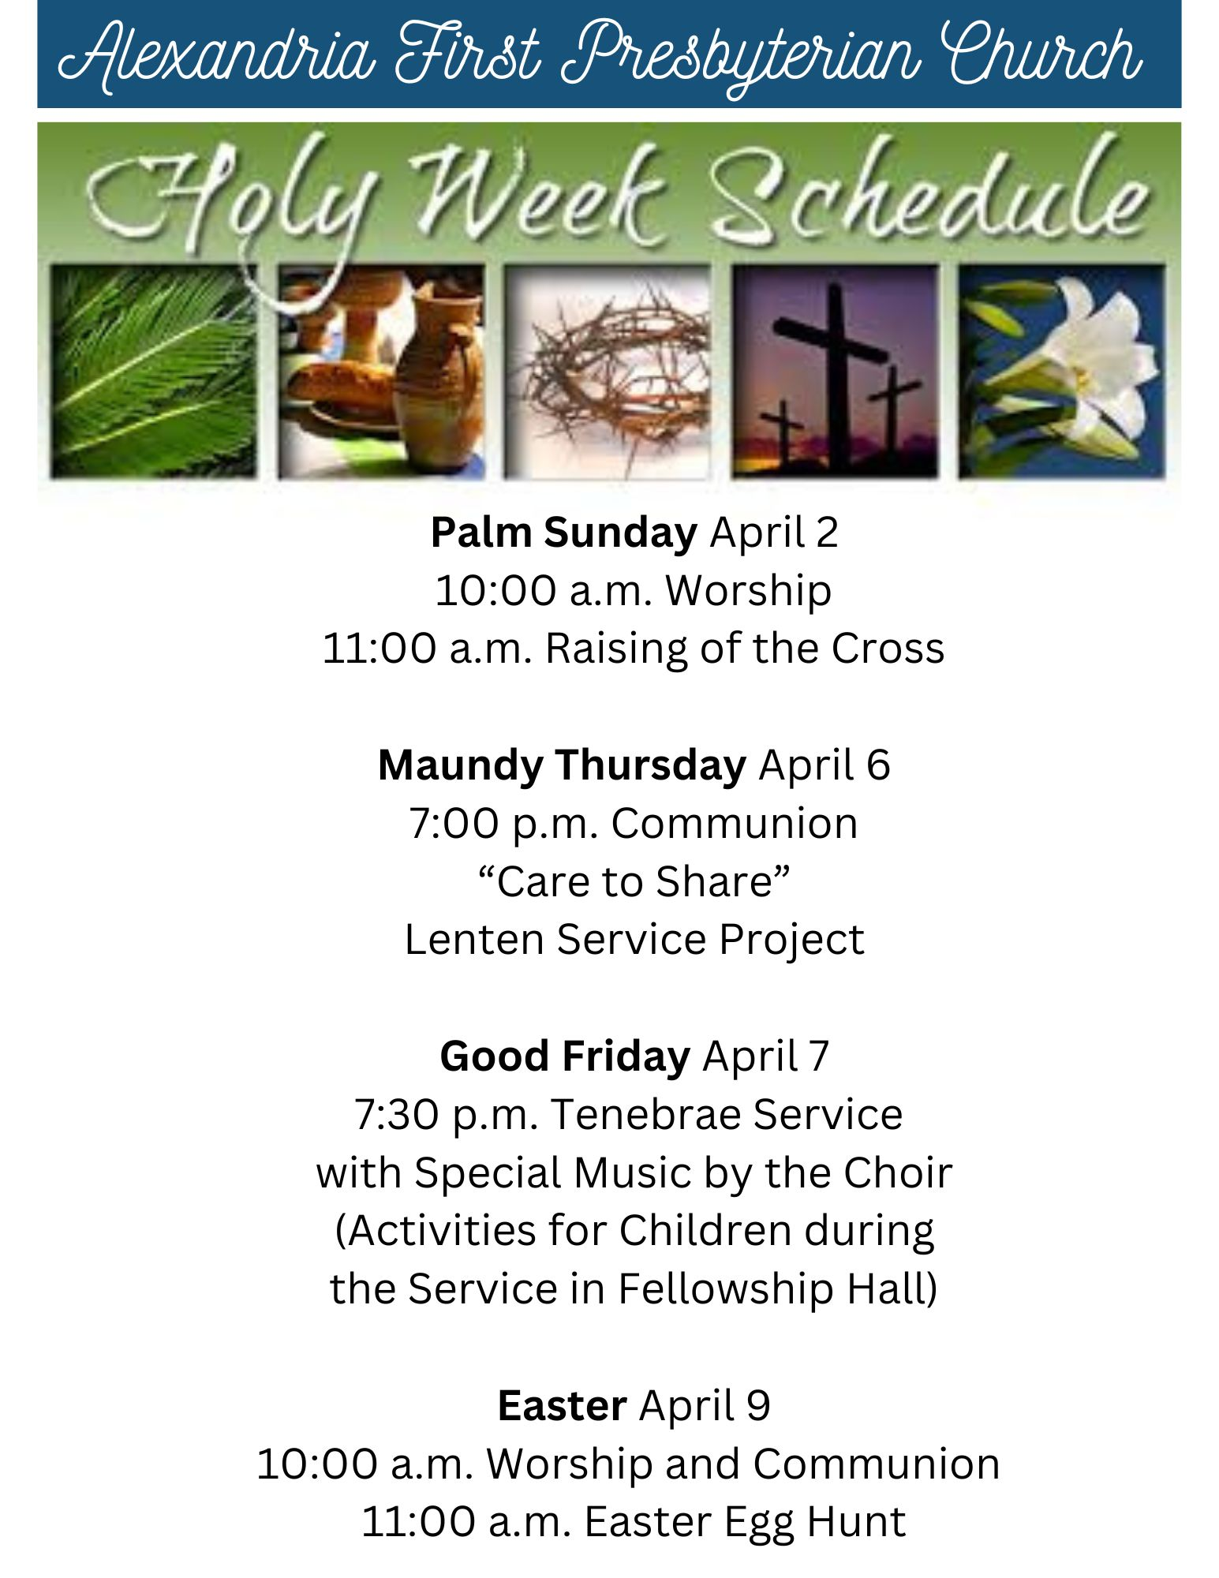

Alexandria First Presbyterian
141 Little York- Mount Pleasant Road
Milford, New Jersey
www.alexpres.org

